Quiz - Week 6: Fluids

- A log is floating in a river where it is 50% submerged. The log reaches the end of the river and enters the ocean. When the log enters the ocean, the level of the water, as measured from the bottom of the log will be-
  - higher than in the river, because of the greater density of ocean water.
  - higher than in the river, due to the higher atmospheric pressure at sea-level.
  - lower than in the river, because ocean water contains a greater amount of dissolved minerals.
  - lower than in the river, because ocean water has a greater temperature than river water.
  - The same height as in the river, because the volume of the log does not change.

- A long, vertical tube is positioned so that the lower end is below the surface of a lake. A vacuum pump is connected to the top of the tube. How high does the water in the tube rise?
  - All the way to the top of the tube.
  - The water in the tube rises to a level equal to the water level of the surrounding lake.
  - Water will not enter the tube.
  - The water will rise exactly 10.418 meters.
  - It cannot be determined without knowing the radius of the tube.

- An aneurysm is the widening of a blood vessel to an abnormally large size. Blood flows through a normal, horizontal blood vessel at a speed of 4 m/s, with a pressure of 15000 pascals. The density of blood is 1025 kg/m³. What is the pressure in a portion where the blood vessel has widened to 2 times its original size?
  - 57125 Pa
  - 21150 Pa
  - 15000 Pa
  - 6150 Pa
  - 2 Pa

- A jellyfish is neutrally buoyant in seawater (r = 1020 kg/m³). The mass of the jellyfish is 10.2 kg. What is its volume?
  - 1 x 10³ m³
  - 1 x 10² m³
  - 1 x 10⁻² m³
  - 1 x 10⁻³ m³
  - It cannot be determined without knowing the density of the jellyfish.

- Scientists believe that mars once had lakes that were very similar to lakes on earth. The gravity on Mars is approximately 3.7 m/s². If a boat that is designed for use in Lake Michigan were placed in a lake on Mars, the boat would -
  - float higher in the water than on Earth.
  - float lower in the water than on Earth.
  - float the same level as on Earth.
  - sink due to no buoyant force existing on Mars.
  - It is impossible to tell without knowing the atmospheric pressure of Mars.

- Water is flowing with a speed of 2 m/s in a square-shaped pipe, with each side measuring 0.1 m in length. It then flows into a triangular section of pipe where the water flows at a speed of 4 m/s. What is the cross-sectional area of the triangular pipe?
  - 2.5 x 10⁻³ m²
  - 5 x 10⁻³ m²
  - 1 x 10⁻² m²
  - 2 x 10⁻² m²
  - 5 x 10⁻² m²

- At the Tootsie Roll® factory, a machine squeezes fudge from a 1-meter radius tank through a nozzle into a 0.5 cm radius roll. If the tank is 3 meters deep, what is the length of the roll that is created?
  - .6 m
  - 1 m
  - 3 m
  - 60 m
  - 6000 m

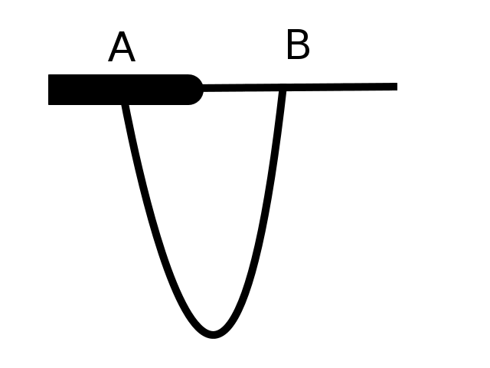
- A glass tube is formed into the shape shown above. A small amount of water is added to the bottom, U-shaped portion of the tube. Air is then blown through the top of the tube. What will happen to the water level on each side of the tube?
  - The water will be higher on side A and lower on side B.
  - The water will be lower on side A and higher on side B.
  - The water will be at the same level on both sides of the tube.
  - It cannot be determined without knowing the direction of the air.
  - It cannot be determined without knowing the velocity of the air.

- A student holds two papers vertically from the top corner of each paper. The papers are separated by a distance of approximately 2 cm. The student then blows a stream of air between the papers. What happens?
  - The papers move away from each other.
  - The papers move toward each other.
  - The papers stay in place.
  - It is impossible to tell without knowing the temperature of the air.
  - It is impossible to tell without knowing the velocity of the air stream.

- A piece of water-ice (r = 900 kg/m³)is dropped into a liquid. The ice will -
  - Float, with 9% of the ice cube submerged.
  - Float with 90% of the ice cube submerged.
  - Be neutrally buoyant.
  - Sink to the bottom of the container.
  - It is impossible to tell without knowing the density of the liquid.

